Transient Electron Dynamics Simulator (TEDs)

v. 1.0.0

User Manual

Introduction

The Transient Electron Dynamics Simulator (TEDs) was designed to model a collection of time-dependent behaviors undergone by excited charge carriers within a nanowire with specified properties. Using SciPy odeint() methods, themselves based on the LSODE methods of the ODEPACK FORTRAN77 library, to evolve initial carrier distributions forward in time, the systems of differential equations can be solved numerically with a relatively simple Python solver. Not so simple, however, is adapting a single Python solver for many nanosystem variants. Editing parameters directly in source code requires relaunching the solver repeatedly. Manually constructing initial distributions is tedious. A solver can get the job done, but a solver operating underneath the hood of a program interface opens many opportunities for utility features to the solver and restores some user friendliness by minimizing the need to interact directly with source code.

With that in mind, the goals of TEDs are to streamline how initial conditions and parameters are fed into the solver and offer more options for how to package the output of the solver. TEDs offers

Table of Contents

Getting Started 3

Setting up TEDs Directories/Folders 3

Familiarizing with the Layout 4

The Inputs Tab - Creating Initial Condition Files 5

Overview 5

Analytical Initial Conditions (AIC) 6

Heuristic Initial Conditions (HIC) 7

Heuristic Mathematical Methods 8

Explicitly Defined Initial Conditions (EIC) 13

Combining Initial Condition Methods 14

Saving and Loading Initial Condition Files 15

The Batch Initial Condition Tool 15

Running Simulations 16

Analyzing and Integrating Simulation Data 17

# Getting Started

config.txt is checked only when TEDs is launched. If config.txt is edited while TEDs is running, TEDs will not notice the changes until it is relaunched.

## Setting up TEDs Directories/Folders

Upon launching the Transient Electron Dynamics Simulator (TEDs), this program will attempt to locate three data storage directories: an Initial Condition directory, a Data directory, and an Analysis directory. By default, these directories are “Initial”, “Data”, and “Analysis”, respectively and their path names are stored in the same directory as the .exe itself. If TEDs cannot find any of these three, it will automatically create them according to the path names in the file **config.txt**. These path names are the default locations in which TEDs will search for all initial condition, simulation, and export files; in other words, if a file is not in these directories, TEDs will not know that it exists.

The path names of each of these directories are stored in **config.txt** and can be modified to change the default locations where TEDs searches for files. With the default directories, **config.txt** looks like the following:

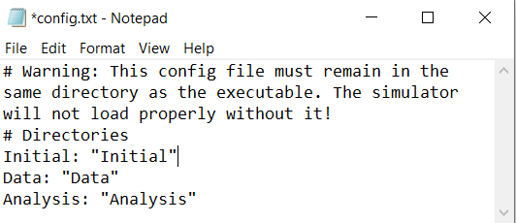

However, the following is an equally valid configuration that tells TEDs to search “TEDs Initial Conditions” for initial condition files, “C:\Users\Larry_Davis \Programs\TEDs” for simulation files, and “Lots_of_Data\Analysis” for analysis files. Note that directories with relative path names (which search in the same directory as the .exe) and absolute path names are both acceptable.

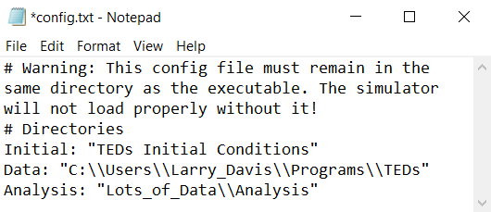

For all path names, all back slashes (\) must be replaced with double back slashes (\\). For example, “C:\\Users\\My_Files” should be entered into config.txt to specify the path name “C:\Users\My_Files”.

All path names must also be enclosed in double quotation marks (“).

## Familiarizing with the Layout

Upon opening the simulator, the following interface is displayed.

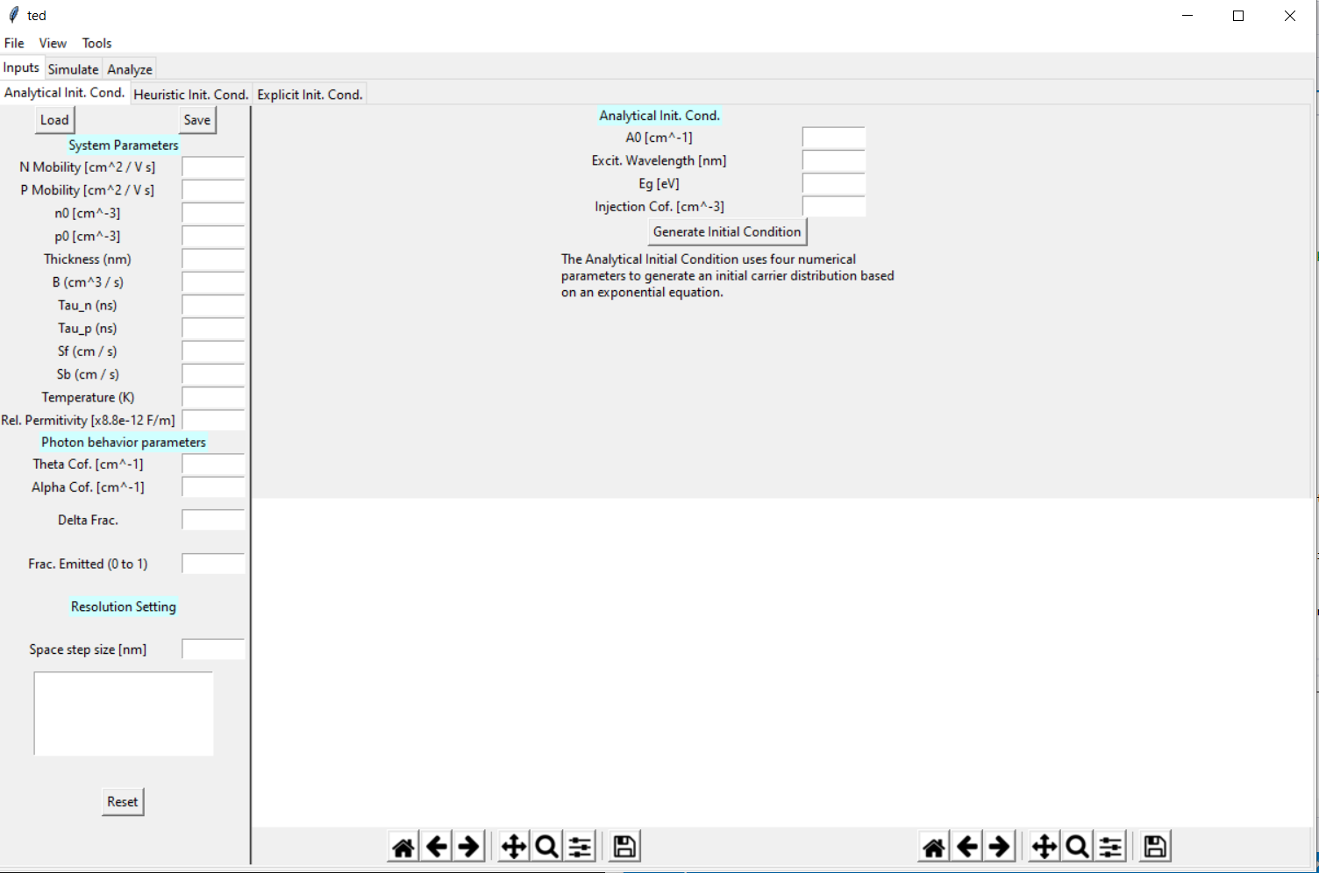

The top left corner contains a menu containing options to close the program, toggle fullscreen view, and open various utility features not contained in the main interface.



The top left corner also contains three tabs—Inputs, Simulate, and Analyze, which correspond to the three main simulation stages of preparing an initial condition and parameter set, simulating the evolution of the initial condition over time, and viewing and analyzing the results. Each of the sub-interfaces displayed by these tabs are described in the following sections.

# The Inputs Tab - Creating Initial Condition Files

## Overview

The inputs tab contains the following major components:

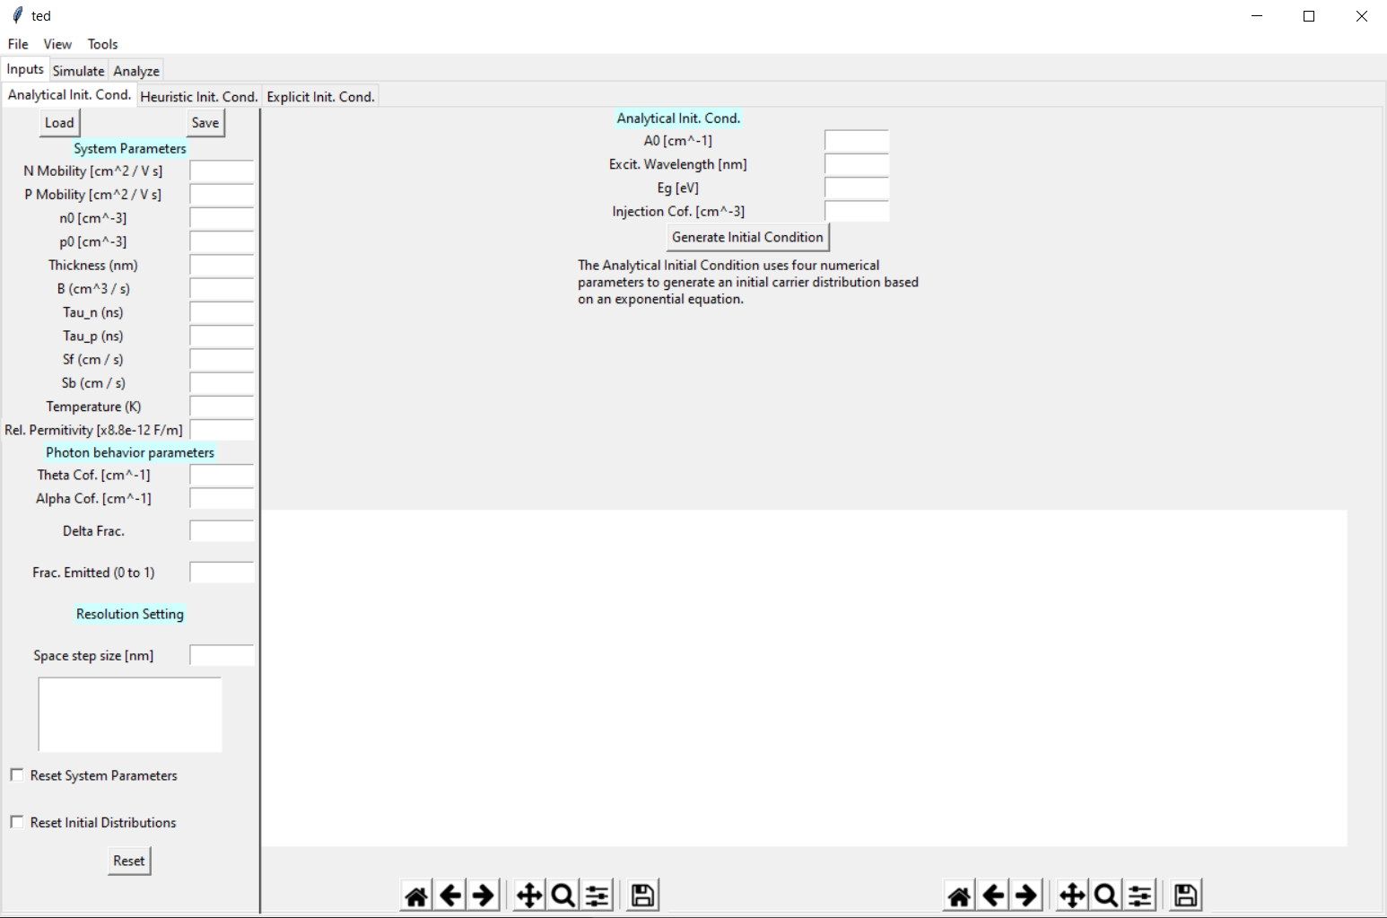

**8**

**7**

**6**

**1**

**2**

**3**

**4**

**5**

1. **Initial Condition Subtabs**

The Inputs Tab itself contains three subtabs – Analytical Initial Condition, Heuristic Initial Condition, and Explicit Initial Condition. While initial condition distribution are zero by default, these three subtabs correspond to three methods available to set values in the initial condition distributions. A choice of subtab here affects the layout presented in [6].

2. **Save and Load Buttons**

These are used to import and export initial condition files, discussed further in the sections *Importing Initial Condition Files* and *Exporting Initial Condition Files*.

3. **Parameter Input Boxes**

Parameters may be entered as numbers – e.g. 100, 9999, or 0.25 – or in scientific notation – e.g. 1e2, 9.999e3, 2.5e-1

The list of system parameters, coefficients, and grid point spacing required by TEDs should be entered in these boxes. The values of the units entered must have the units indicated by the labels to the left of each box.

4. **Status Window**

This box displays status and error messages associated with managing the initial conditions. If a problem occurs while importing, editing, or exporting an initial condition, the issue will be named in this box.

5. **Full Reset Button**

There is no “Are you sure?” confirmation when clicking the Full Reset Button – use this button with care!

This button clears all unsaved system parameters and initial condition distributions from the interface, depending on the checked options, and is useful for preparing an initial condition file from a blank template. Note that this feature does not in any way affect the contents of previously saved initial condition files.

6. **Initial Condition Generation Suite**

The layout of this area and options available changes depending on which tab of [1] is selected. Details regarding how each of the generation suites operate are available in the subsections *Analytical Initial Conditions (AIC), Heuristic Initial Conditions (HIC), and Explicitly Defined Initial Conditions (EIC)*.

7. **Initial Condition Plots**

Each of these two plots present a visualization of the initial distribution – ΔN and ΔP in the left plot, and E­­g and χ in the right plot.

8. **Plot Options**

These toolbars offer resizing and scaling of the Initial Condition Plots as well as options to export images of the plots.

## Analytical Initial Conditions (AIC)

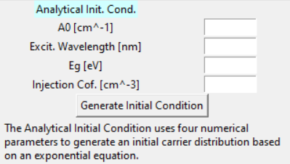

Using the four parameters (A0), Excitation Wavelength (λ), Bandgap (E­g), and Injection Coefficient (C), this mode assigns values to ΔN and ΔP at each space point across the entire length of the nanowire using the following equations:

TEDs automatically performs all unit conversions needed to obtain ΔN and ΔP in carriers/nm3 from values inputted in the listed units.

## Heuristic Initial Conditions (HIC)

The HIC mode offers a fast, versatile way to sketch initial condition profiles by inputting a list of mathematical rules (heuristics). Key parts of this interface are:

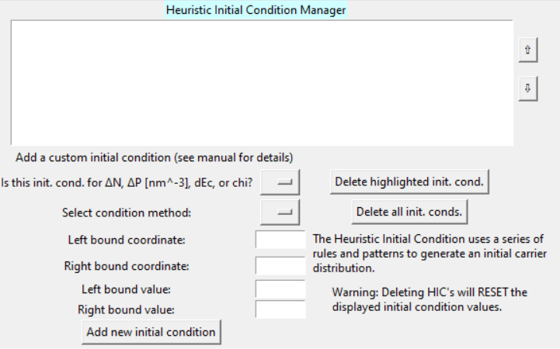

**5**1. **Initial Condition Subtabs**

The Inputs Tab itself contains three subtabs – Analytical Initial Condition, Heuristic Initial Condition, and Explicit Initial Condition. These three subtabs correspond to three methods available to generate initial condition distributions and affect the layout presented in [6].

2. **Save and Load Buttons**

These are used to import and export initial condition files, discussed further in the sections *Importing Initial Condition Files* and *Exporting Initial Condition Files*.

3. **Parameter Input Boxes**

The list of system parameters, coefficients, and grid point spacing required by TEDs should be entered in these boxes. The values of the units entered must have the units indicated by the labels to the left of each box.

4. **Status Window**

This box displays status and error messages associated with managing the initial conditions. If a problem occurs while importing, editing, or exporting an initial condition, the issue will be named in this box.

**3**

**4**1. **Initial Condition Subtabs**

The Inputs Tab itself contains three subtabs – Analytical Initial Condition, Heuristic Initial Condition, and Explicit Initial Condition. These three subtabs correspond to three methods available to generate initial condition distributions and affect the layout presented in [6].

2. **Save and Load Buttons**

These are used to import and export initial condition files, discussed further in the sections *Importing Initial Condition Files* and *Exporting Initial Condition Files*.

3. **Parameter Input Boxes**

The list of system parameters, coefficients, and grid point spacing required by TEDs should be entered in these boxes. The values of the units entered must have the units indicated by the labels to the left of each box.

4. **Status Window**

This box displays status and error messages associated with managing the initial conditions. If a problem occurs while importing, editing, or exporting an initial condition, the issue will be named in this box.

**2**

**1**

1. **Heuristic List Window**

When a new heuristic is added, a brief description if it will be added to this window. TEDs applies each of these heuristics one at a time, in order from top to bottom, to construct initial condition distributions for the indicated variables.

2. **Heuristic Reordering Buttons**

Heuristics in [1] can be selected with a click and can be reordered in the list using these buttons. As mentioned, the order of which heuristics appear in the list is the order in which TEDs will apply them to the initial condition distribution.

3. **Heuristic Input Boxes**

These items are used to, for a new heuristic, specify the variable for which it should be applied, the mathematical method used to apply it, and the values that the method should use. There are four mathematical methods – POINT, FILL, LINE, and EXP, and each of these are discussed in the following section *Heuristic Mathematical Methods*.

4. **Deletion Buttons**

These buttons are used to delete either the selected heuristic or clear all heuristics from the initial conditions.

**5. Add Button**

This button constructs a new heuristic from the parameters specified in [3], adds it to TEDs’s internal list of heuristics, and displays it in [1].

## Heuristic Mathematical Methods

Four mathematical methods are available for HIC – POINT, FILL, LINE, and EXP.

The POINT method is by far the most straightforward, assigning the Left Bound Value to the selected variable’s initial distribution at the location specified by Left Bound Coordinate. In the following example, this method is applied twice to create some very pointy ΔN and ΔP initial distributions.

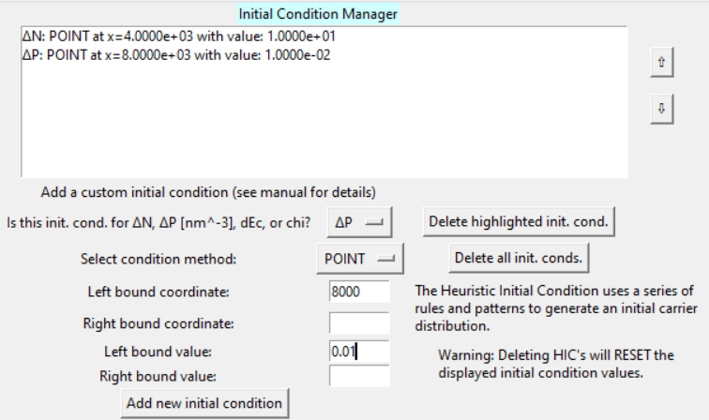

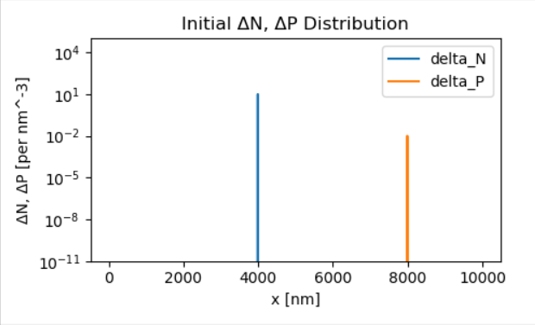

The FILL method fills every space point from the Left Bound Coordinate to the Right Bound Coordinate with the Left Bound Value. This method is useful for specifying regions with constant initial values and is a special case of the LINE method.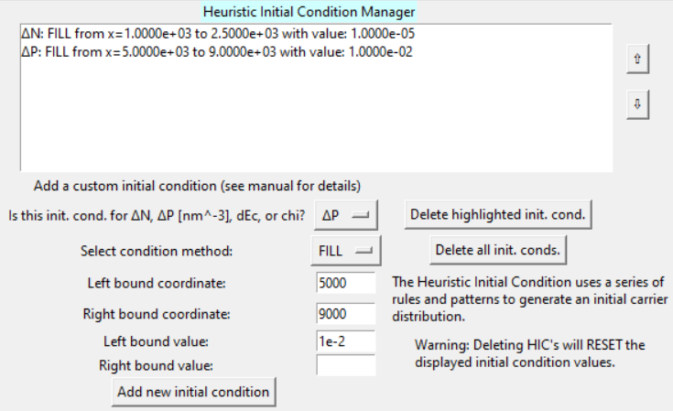

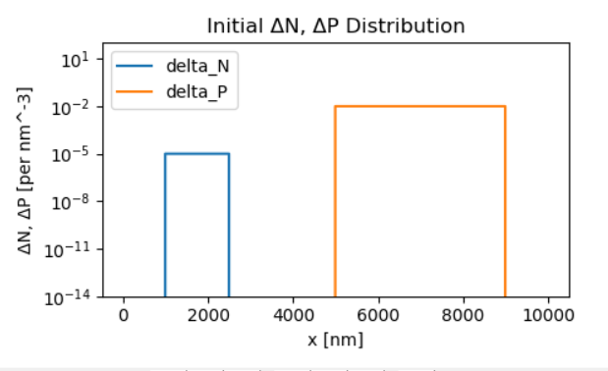

The LINE method assigns the Left Bound Value to the Left Bound Coordinate, assigns the Right Bound Value to the Right Bound Coordinate, and performs linear interpolation to assign values to all intermediate space points. Each intermediate point differs from its neighbors by a common difference. As the following example shows, straight lines do not always appear straight on logarithmic-scaled plots.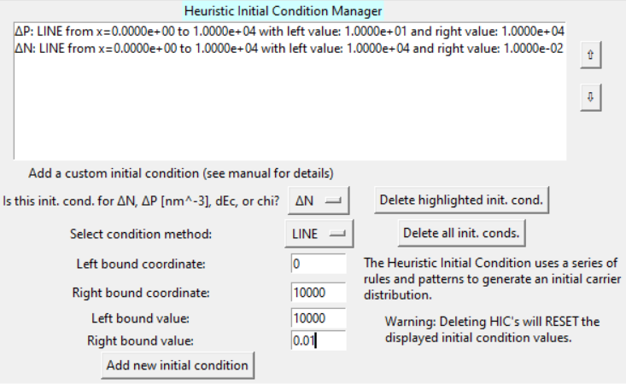

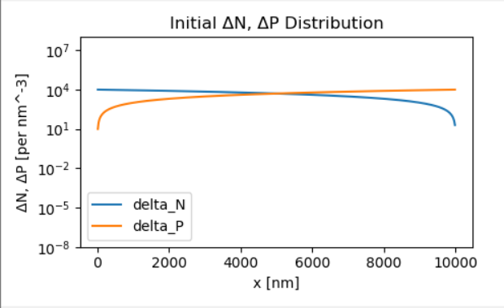

The EXP method is similar to LINE, but intermediate space points are instead filled by exponential interpolation between the left and right bounds. Each intermediate point differs from its neighbors by a common ratio.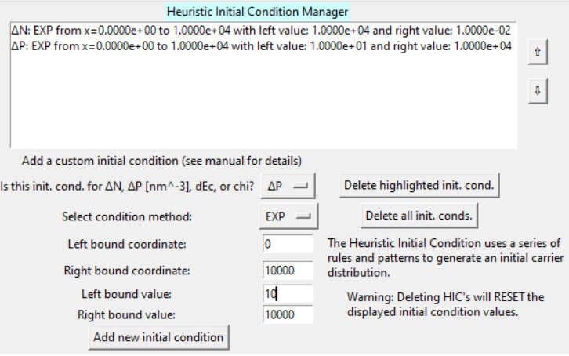

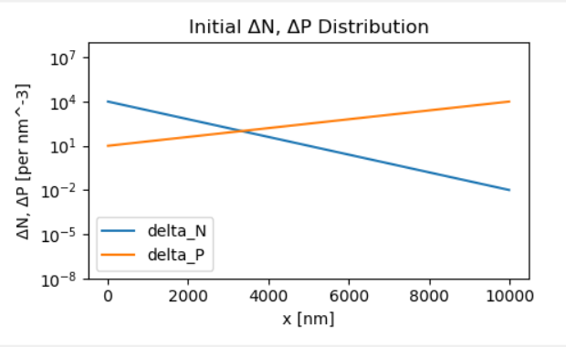

Linear interpolations do not appear linear on a log-scaled plot, but exponential interpolations do.

These four methods can be combined to set up very complex distributions.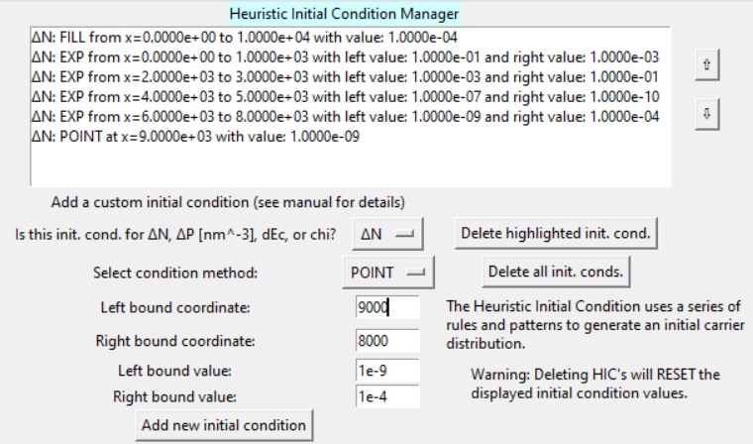

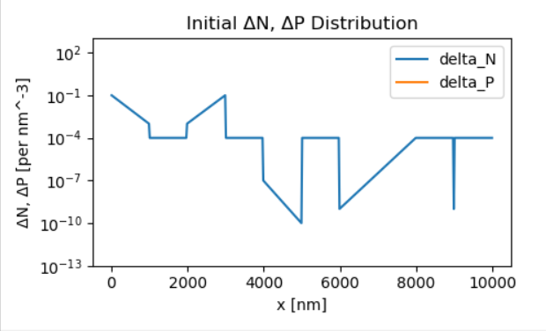

## Explicitly Defined Initial Conditions (EIC)

Copying from Microsoft Excel causes the data to be pasted into most text editors as tab-separated columns – a fast way to create properly formatted EIC files!

Finally, TEDs can accept custom initial distributions in the form of .txt files containing lists of space coordinate and value pairs and apply these to a selected variable. Any space coordinates between those specified in the file will be filled in by linear interpolation. These .txt files must be formatted as two tab-separated columns, with the first column for coordinates and the second column for values.

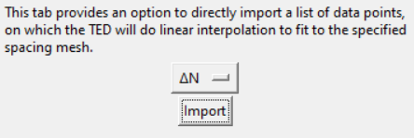

In the following example, the EIC file “points.txt” is applied to ΔN over the range z=0 nm to z=6000 nm.

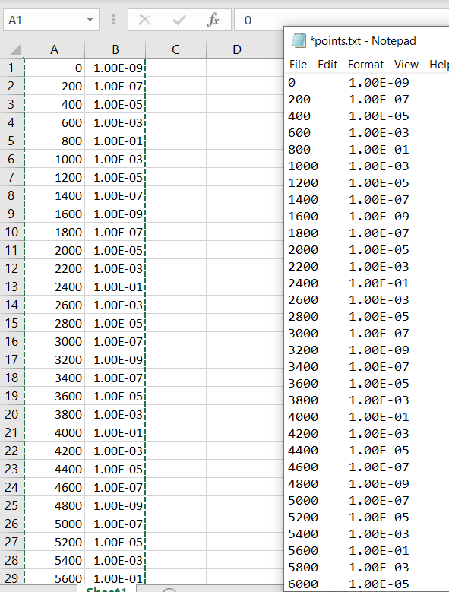

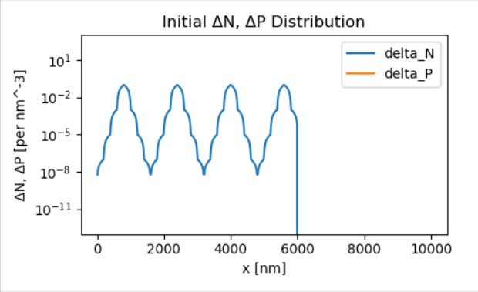

## Combining Initial Condition Methods

All three initial condition methods – AIC, HIC, and EIC, may be used in conjunction to represent virtually every possible initial distribution. In this example, EIC is used to apply the “points.txt”, but two FILL HICs are used to add steps starting at x=6500 nm and x=8000 nm. 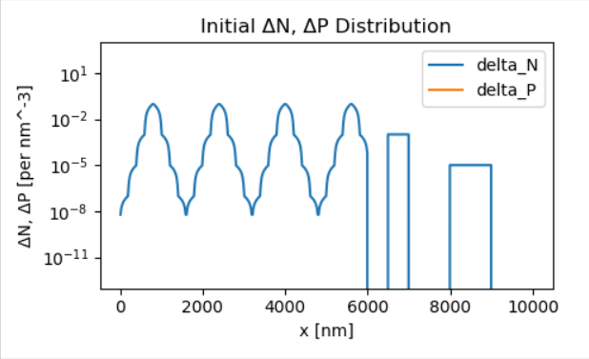

When combining initial conditions, order is important – new initial conditions whose bounds overlap preexisting initial conditions will override the area of overlap with new values. In this example, a FILL HIC is instead placed at x=2000 nm after the EIC is applied, cutting off one of the EIC’s peaks.

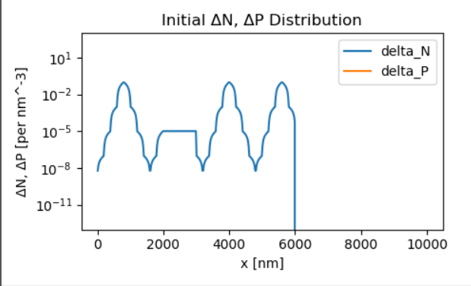

If the EIC were applied after the FILL HIC, rather than before, the wide span of the EIC would essentially smother the HIC and produce the example shown in the section *Explicitly Defined Initial Conditions*.

Of course, this overlapping behavior can itself be used to construct more complex initial conditions.

## Saving and Loading Initial Condition Files

Before TEDs can use initial condition distributions and system parameter sets, these must be saved as initial condition files (ICFs) using the “Save” feature.

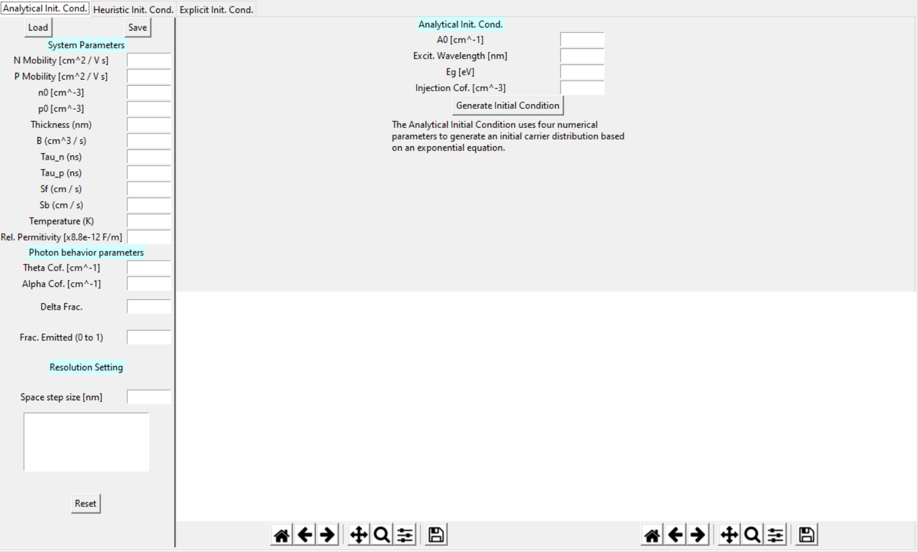

Saving an ICF without all system parameters entered is not allowed, but saving an ICF without initial distributions is possible. In that case, all of the distributions would be saved as their default values – zeroes.

Once all system parameters have been entered, clicking the “Save” button will allow you to create and name a new initial condition file. ICFs have a specific layout designed to inform TEDs of where different items are located in the file.

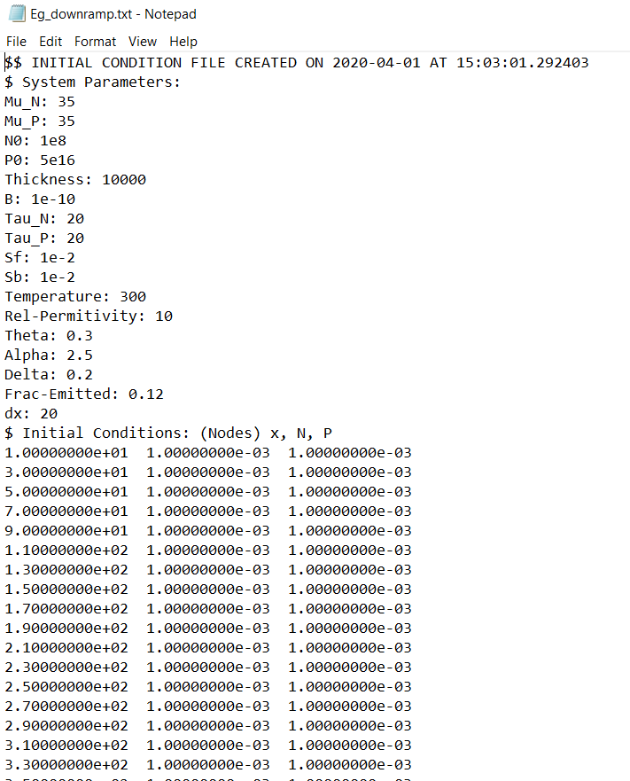

The order of sections, however, must always be System Parameters, then Initial Conditions (Nodes), then Initial Conditions (Edges).

The order of system parameters seen in this example is the order in which TEDs will save them, but TEDs can load and read these in any order. An ICF like this one whose System Parameters section starts with Temperature and ends with Theta, for instance, is perfectly compatible.

The first line of an ICF contains a timestamp of when the file was created; immediately following that is the “$ System Parameters” section, which contains a list of the system parameters. The second and third sections, “$ Initial Conditions: (Nodes)” and “$ Initial Conditions: (Edges)”, represent the lists of values that form the initial condition distribution at every data point.

These lists are also tab-separated and directly pastable from Excel.

## The Batch Initial Condition Tool

In many situations, such as sensitivity analyses, it is useful to generate many initial condition files that differ from one other by only a single parameter. In the “Tools” menu, TEDs offers the Batch Initial Condition Tool, which provides a fast method to generate many such copies based on an existing initial condition.

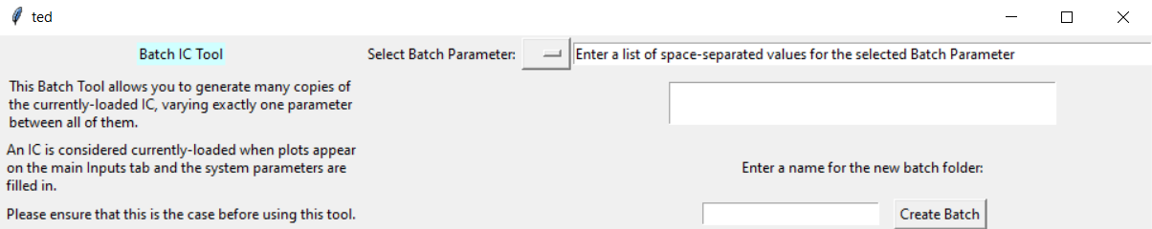

In the following example, the Batch Initial Condition Tool is used to generate copies of “Eg_downramp.txt” from *Saving and Loading Initial Conditions* with varying values of the parameter Tau_N: 10, 25, 40, 100, 1 000, and 10 000.

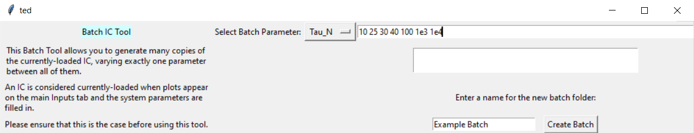

When “Create Batch” is clicked, a directory is created within the Initial Directory specified in config.txt, alongside any existing initial condition files. Each file in the batch is procedurally named using the value of the varied parameter it has adopted.

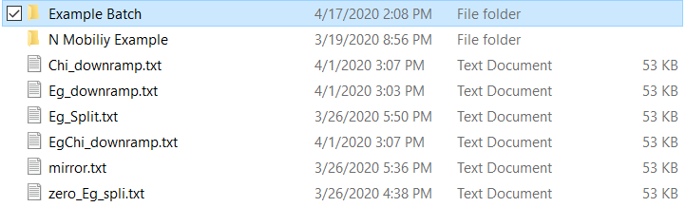

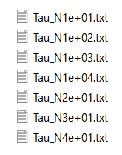

## Removing Initial Condition Files (or any TEDs Files)

In the top left corner menu under “File”, TEDs provides a series of shortcuts to each of the default directories.

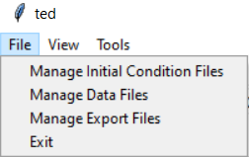

Each of these opens the corresponding default directory, from where any files created by TEDs can be deleted.

# Running Simulations

The simulate tab contains the following major components:

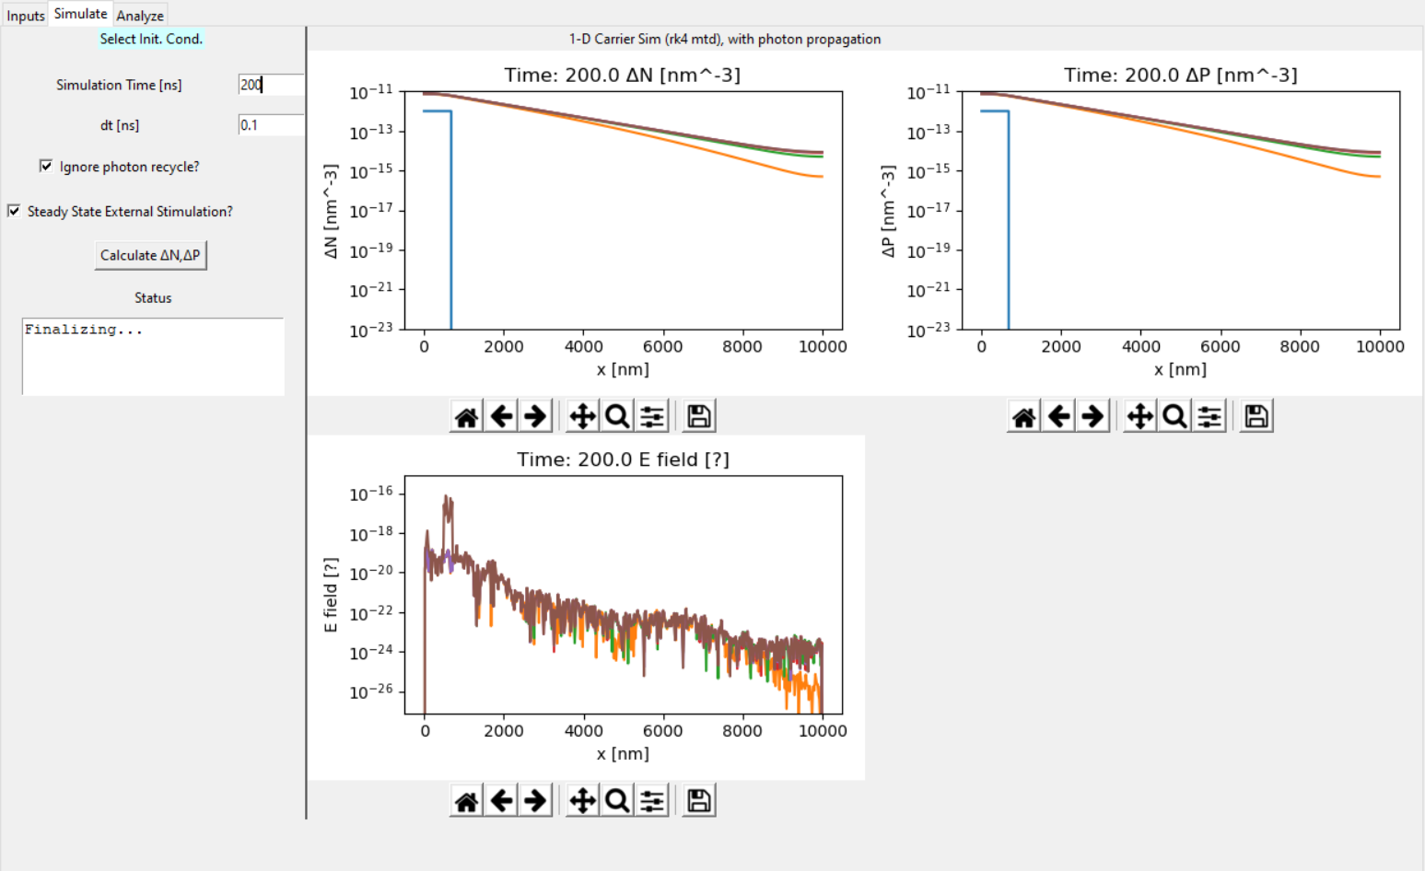

**3**

**2**

**1**

**4**

1. **Simulation Parameters and Options**

This area contains input boxes in which the total time over which the nanowire should be modeled and the time step size this total should be partitioned into, as well as options to modify the behavior of the system.

If “Ignore Photon Recycle” is checked, TEDs will neglect charge carrier regeneration due to photons propagating down the nanowire. This approximation makes the simulation slightly less accurate at early times but greatly increases the speed of the calculations overall.

All other behaviors, such as photon escape and photon propagation *without* charge carrier regeneration, will remain active.

If “Steady State External Stimulation” is checked, TEDs will treat the initial condition distribution as a constantly applied external stimulation rather than an initial burst. The initial condition distributions will not only be the starting state of the nanowire, but the initial ΔN and ΔP will be added to the nanowire every nanosecond.

2. **Calculate Button**

When this button is clicked, a prompt opens for selecting previously saved ICFs. Multiple files may be selected and TEDs will simulate each of these in series with the settings in [1].

When a simulation is complete, TEDs will create a folder in the “Data” directory specified in config.txt containing the results of the simulation. The name of this folder is based on the name of the ICF used to run the simulation.

3. **Status Window**

Like its counterpart in the inputs tab, this window displays status messages and problems encountered when simulating the nanowire.

4. **Results Plots**

These plots display snapshots of time steps taken during the simulation, a useful first glance of how the nanowire is evolving over time. As with the initial tab plots, each of these plots has a toolbar for basic resizing and exporting.

# Analyzing and Integrating Simulation Data

The analyze tab contains two smaller plots – for navigating through the time steps of selected data sets, and one larger plot – for showing results from integrating data sets from the smaller plots.

The defining feature of this tab is that each plot is equipped with a more detailed toolbar, and the workings of each button are covered in the following sections.

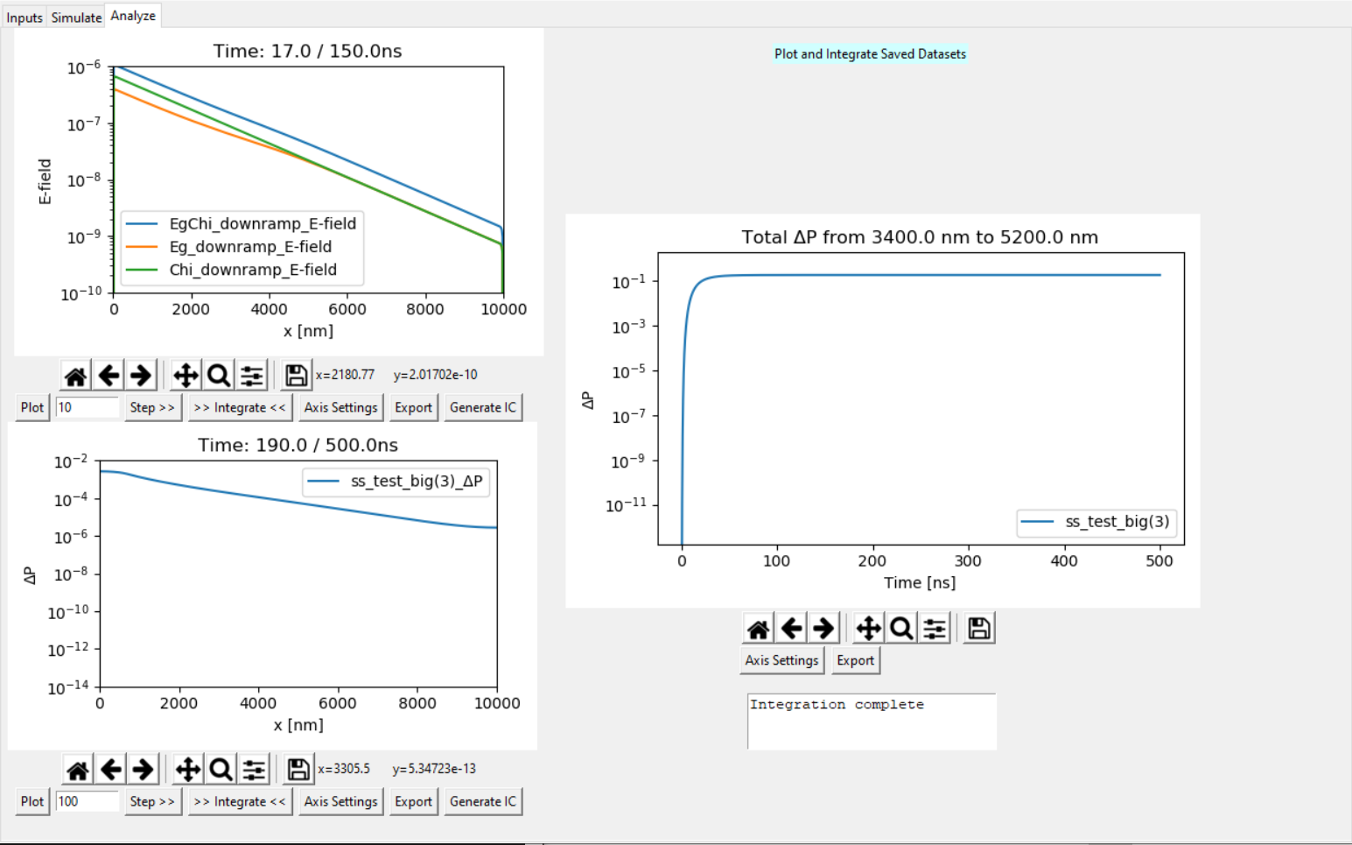

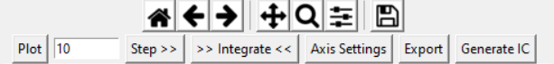

## Plotting

The “Plot” button opens the following popup, from which there are options to select which variable should be plotted on the y-axis and which data sets should be plotted.

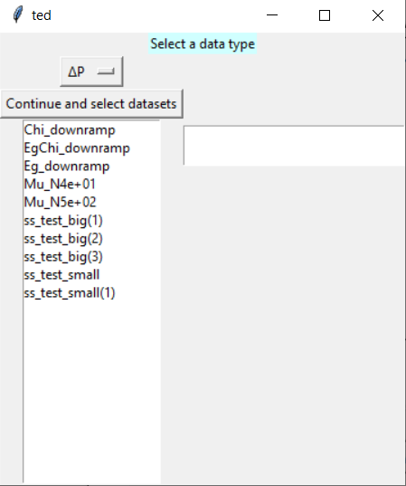 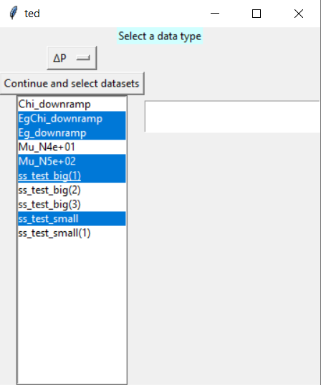

To select a single dataset, click its name in the box.

To select multiple datasets, hold the **Ctrl** key and drag the cursor over every desired dataset.

Excel users will notice that TEDs uses the same multiple cell selection scheme as Excel.

When “Continue and select datasets” is clicked, the first time step of each selected dataset (that is, the initial condition) is plotted.

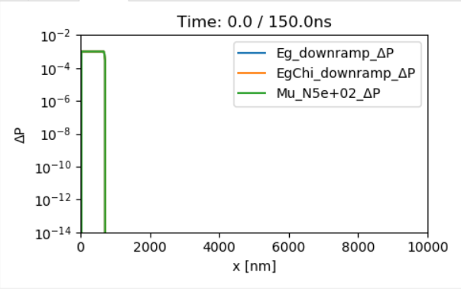

Datasets with different **space** step sizes, however, are compatible with one another.

One major limitation, as demonstrated above by the fact that only three of the five selected datasets have been plotted, is that the plotter can only plot datasets together if they have the same total time and time step size. If datasets with different total time or time step size should be compared, plotting each on a different plot is recommended.

## Stepping Datasets Through Time

Directly to the right of the “Plot” button is the “Step” input box and button. When the “Step” button is clicked, all plotted datasets are advanced by the number of time steps specified in the input box. How far ahead the datasets are advanced in absolute time depends on the size of the time steps used in the simulation.

With a time step size of 0.1 ns, for example, entering 180 will advance the datasets by 18.0 ns. each time the “Step” button is clicked.

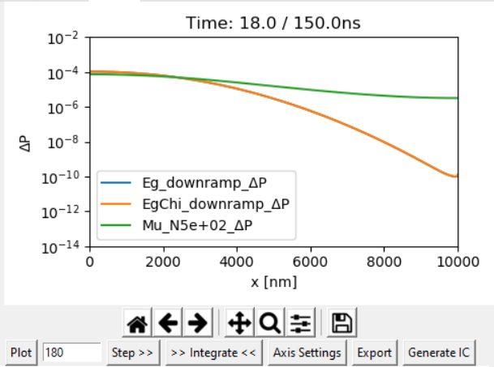

Stepping with a negative number of time steps will cause TEDs to move the datasets **backward** that many time steps.

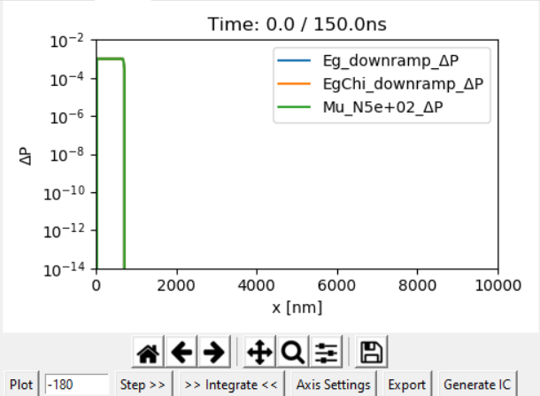

## Changing Axis Settings

The “Axis Settings” button opens a popup to change the lower bounds, upper bounds, and scaling type of the x and y axes.

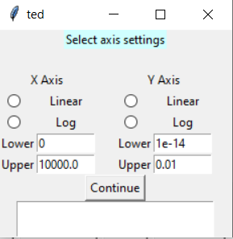

## Exporting Data

The “Export” button opens a prompt to save the currently plotted data to a .csv file, which can be viewed with Excel or any text editor. These files have an alternating column format – the first and second columns are the (x, y) data points of the first data set, the third and fourth columns are (x, y) for the second data set, and so on.

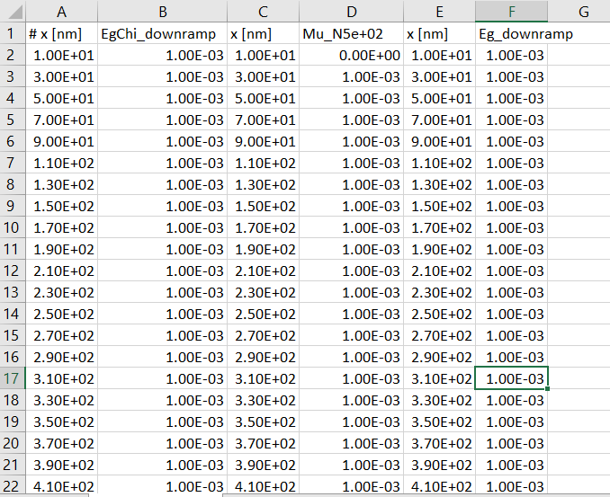

## Carrying Existing Data into New Initial Conditions

Finally, the “Generate IC” button opens a popup that can be used to construct a new ICF from previously simulated datasets.

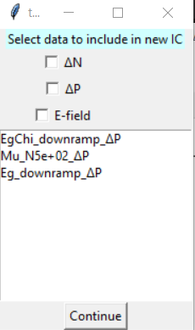

Unselected variables will be filled in with the default value – zero.

First, the checkboxes are used to indicate which variables should be used to generate initial condition distributions. The selection box, which functions like the “Plot” button’s, is then used to indicate which datasets ICFs should be generated for. When “Continue” is clicked, one ICF will be created with the selected variables for each dataset and prompts will appear to name the ICFs.

These ICFs can then be modified further or simulated using TEDs’ other tabs.

## Integration

TEDs supports two integration modes – “Over Time”, which integrates the plotted variable over a specified space interval at all time steps and generates a plot of how the integrated variable evolves over time, and “Current Time Step”, which integrates over the space interval at only the currently displayed time step. Because the horizontal axis is not used for time in the “Current Time Step” mode, the user is free to assign any variable to this axis. Combined with the batch initial condition tool, the “Current Time Step” mode is useful for sensitivity analyses over single parameters.

For example, we may want to examine how the carrier density near the front of the nanowire is affected by the negative charge carrier mobility “Mu_N”, but a plot of the spatial distributions can be quite chaotic.

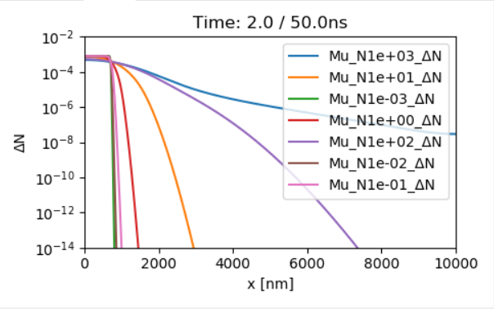

Upon clicking “Integrate”, the following popup appears for selecting the integration mode.

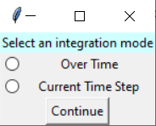 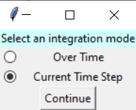

When “Continue” is clicked, the next popup appears for specifying the lower and upper space boundaries of the integration.

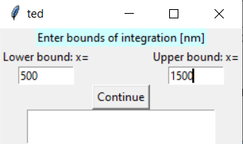

If the “Current Time Step” mode is selected, a third popup will appear for selecting the variable to be plotted on the horizontal axis.

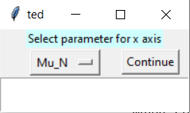

The following plot is generated, but adjusting the vertical axis using the “Axis Settings” should prove helpful.

